ITCS-6190 Assignment 3
AWS Data Processing Pipeline
End-to-End Serverless Pipeline: S3 → Lambda → Glue → Athena → EC2 Dashboard

Step 1: Amazon S3 Bucket Setup 🪣
Created S3 bucket cc-assignment-92 (us-east-1) with three folders: raw/, processed/, and enriched/.

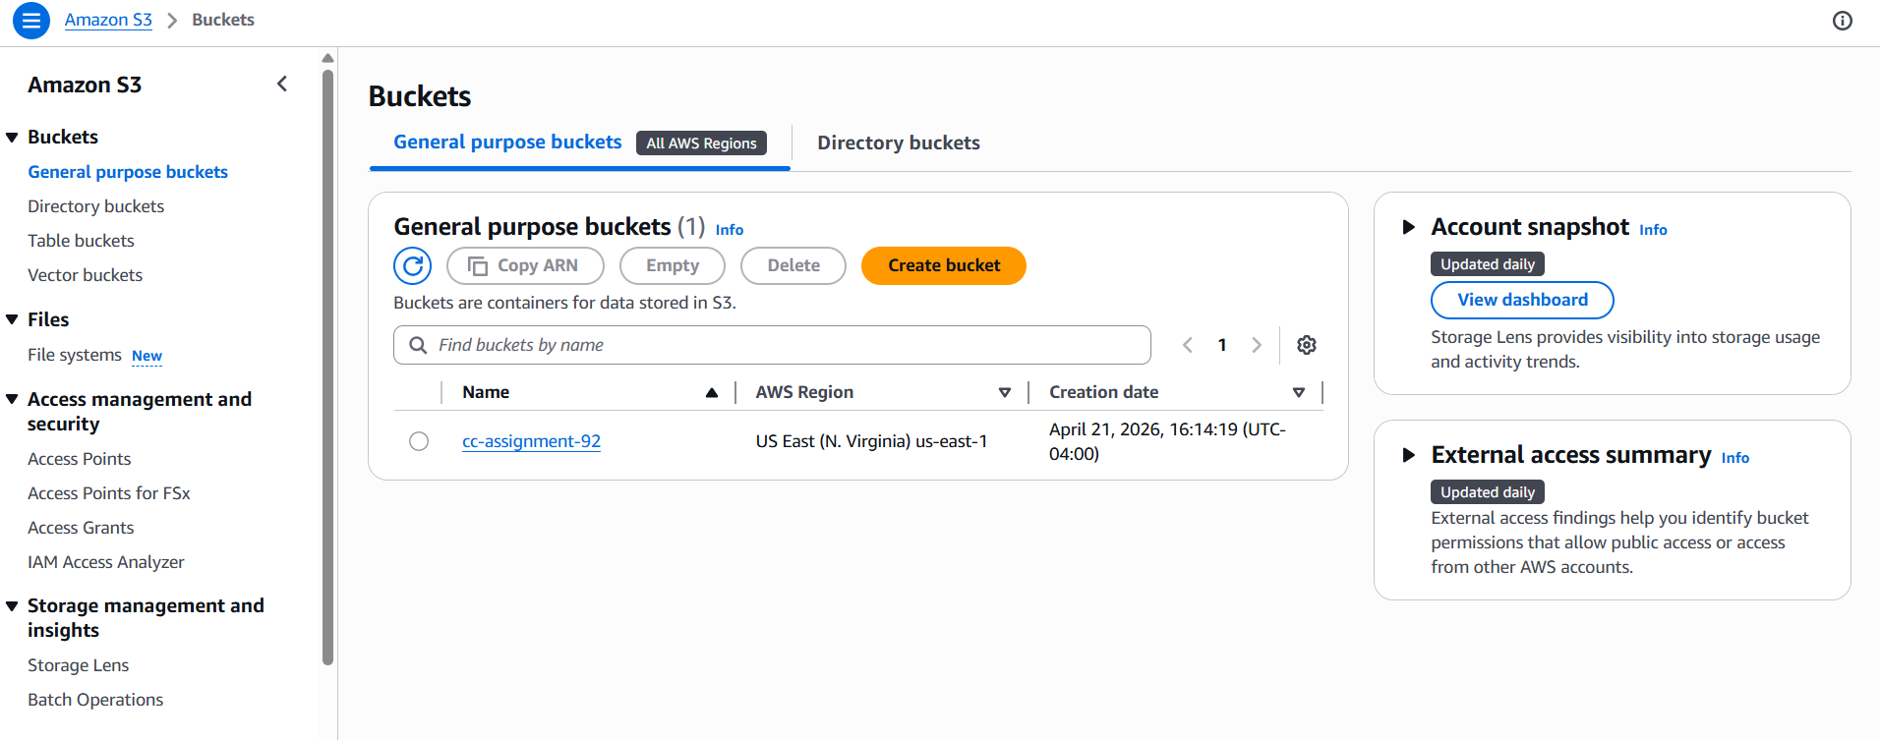
S3 Bucket: cc-assignment-92 created in us-east-1

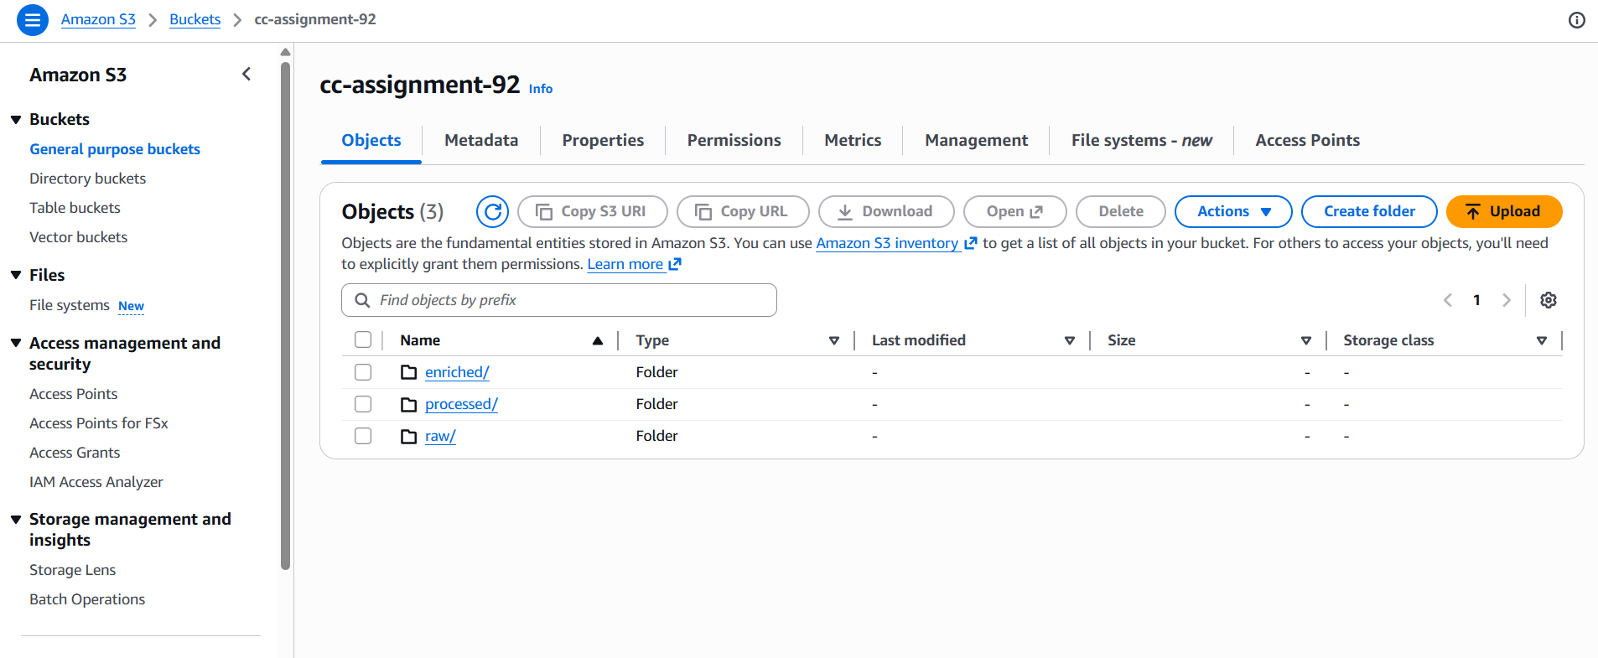
S3 Folder Structure: raw/, processed/, enriched/

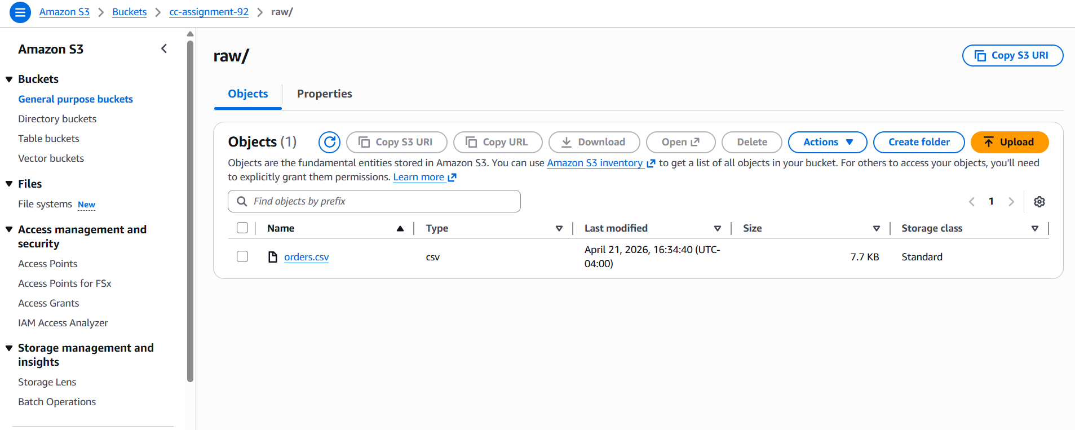
raw/ folder containing orders.csv (7.7 KB)

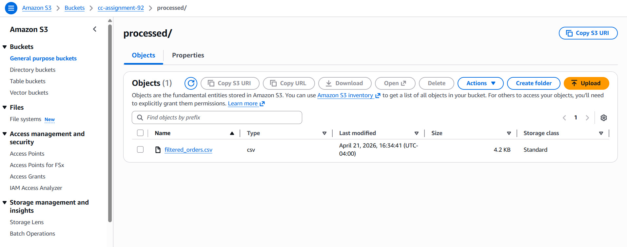
processed/ folder containing filtered_orders.csv generated by Lambda

Step 2: IAM Roles and Permissions 🔐
Created three IAM roles for Lambda, Glue, and EC2 with required permissions.
- Lambda-S3-Processing-Role: AWSLambdaBasicExecutionRole + AmazonS3FullAccess
- Glue-S3-Crawler-Role: AmazonS3FullAccess + AWSGlueConsoleFullAccess + AWSGlueServiceRole
- EC2-Athena-Dashboard-Role: AmazonS3FullAccess + AmazonAthenaFullAccess

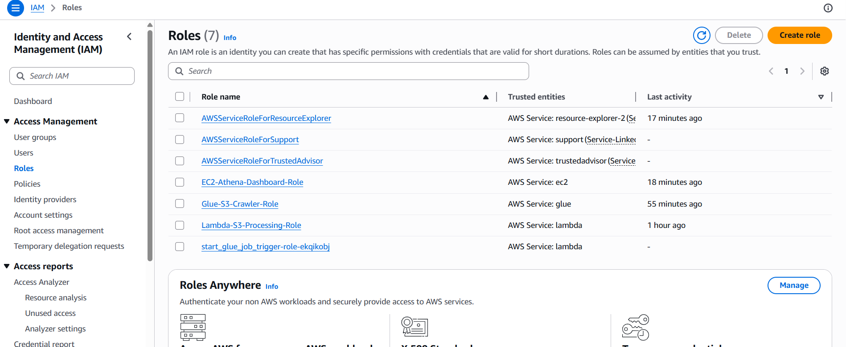
IAM Roles: All three roles created successfully

Step 3: Lambda Function ⚙️
Created Lambda function FilterAndProcessOrders using Python 3.14 runtime with Lambda-S3-Processing-Role.

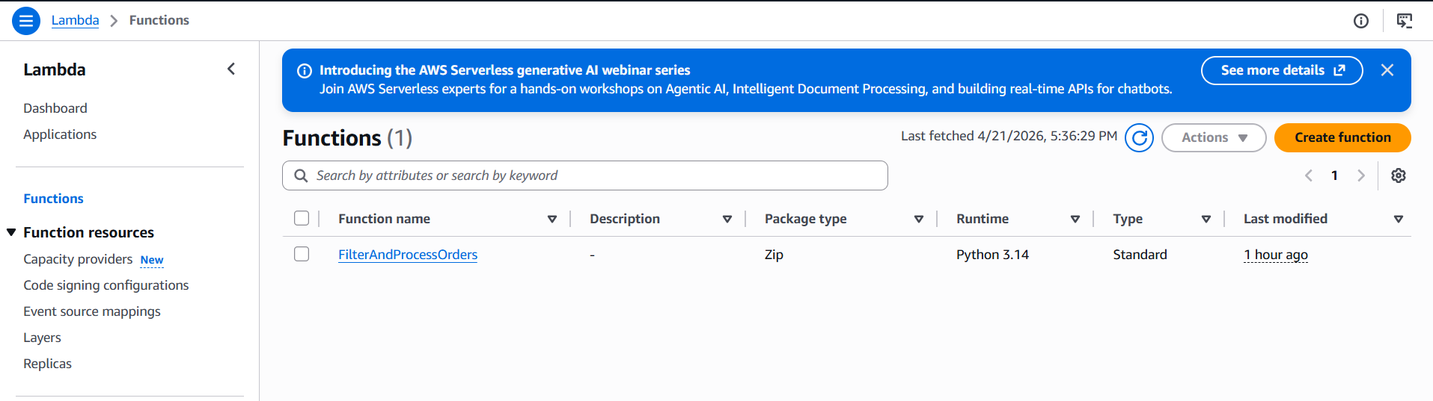
Lambda Function: FilterAndProcessOrders created (Python 3.14)

Step 4: S3 Trigger Configuration ⚡
Configured S3 trigger on cc-assignment-92 bucket to invoke Lambda on all object create events with prefix raw/ and suffix .csv.

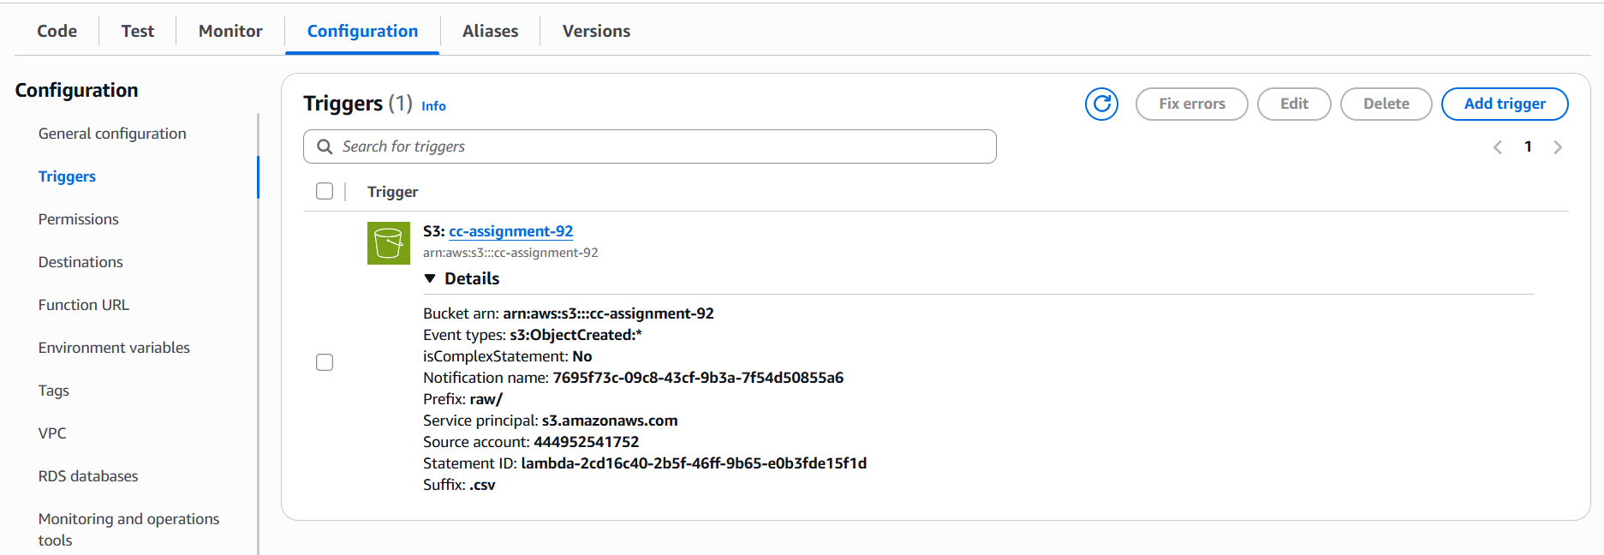
S3 Trigger: Configured with prefix raw/ and suffix .csv on bucket cc-assignment-92

Step 5: AWS Glue Crawler 🕸️
Created and ran orders_processed_crawler pointing to processed/ folder in S3. Crawler successfully created 1 table in orders_db database.

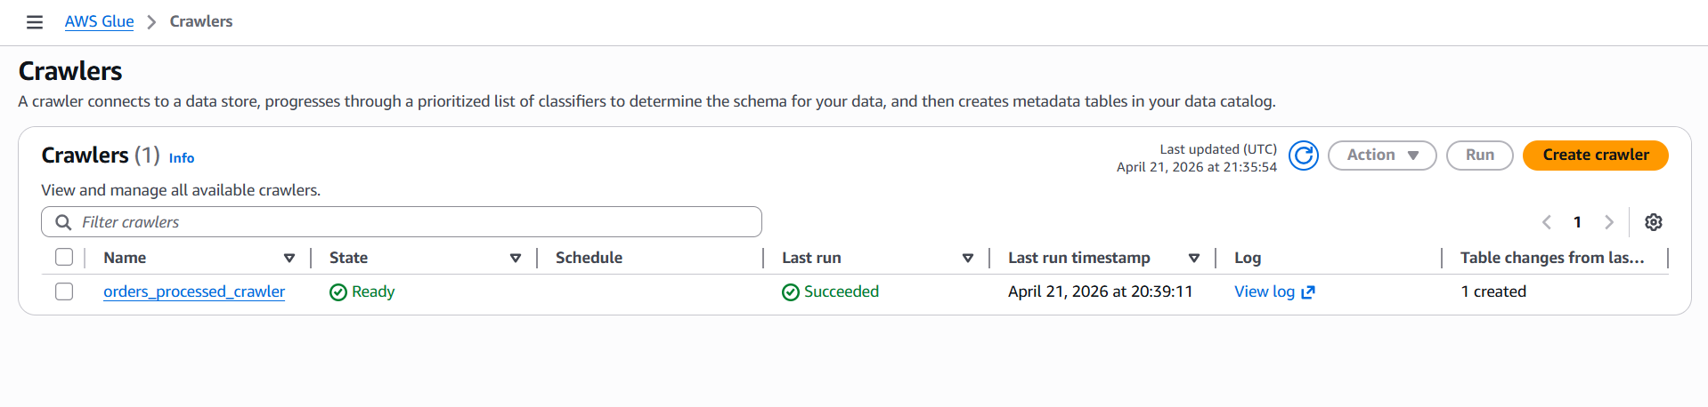
Glue Crawler: orders_processed_crawler ran successfully, 1 table created

Step 6: Amazon Athena Queries 🔍
Executed 5 SQL queries against orders_db database (table: processed) using Amazon Athena Query Editor.

Query 1: Total Sales by Customer
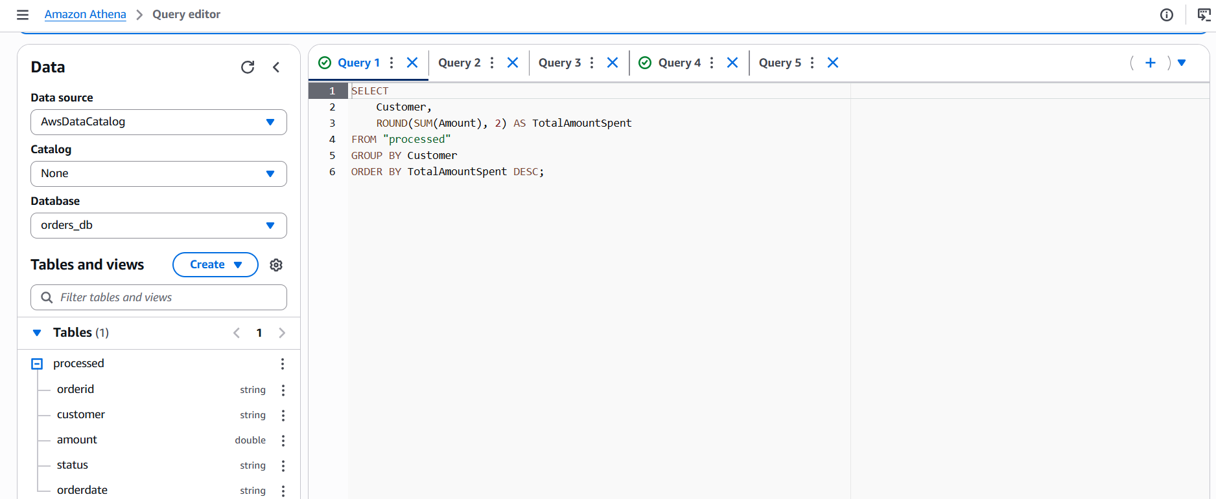

Query 2: Monthly Order Volume and Revenue
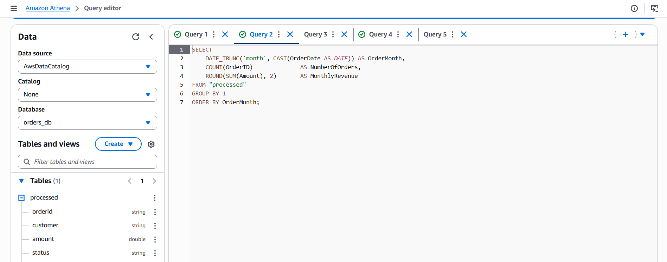

Query 3: Order Status Dashboard
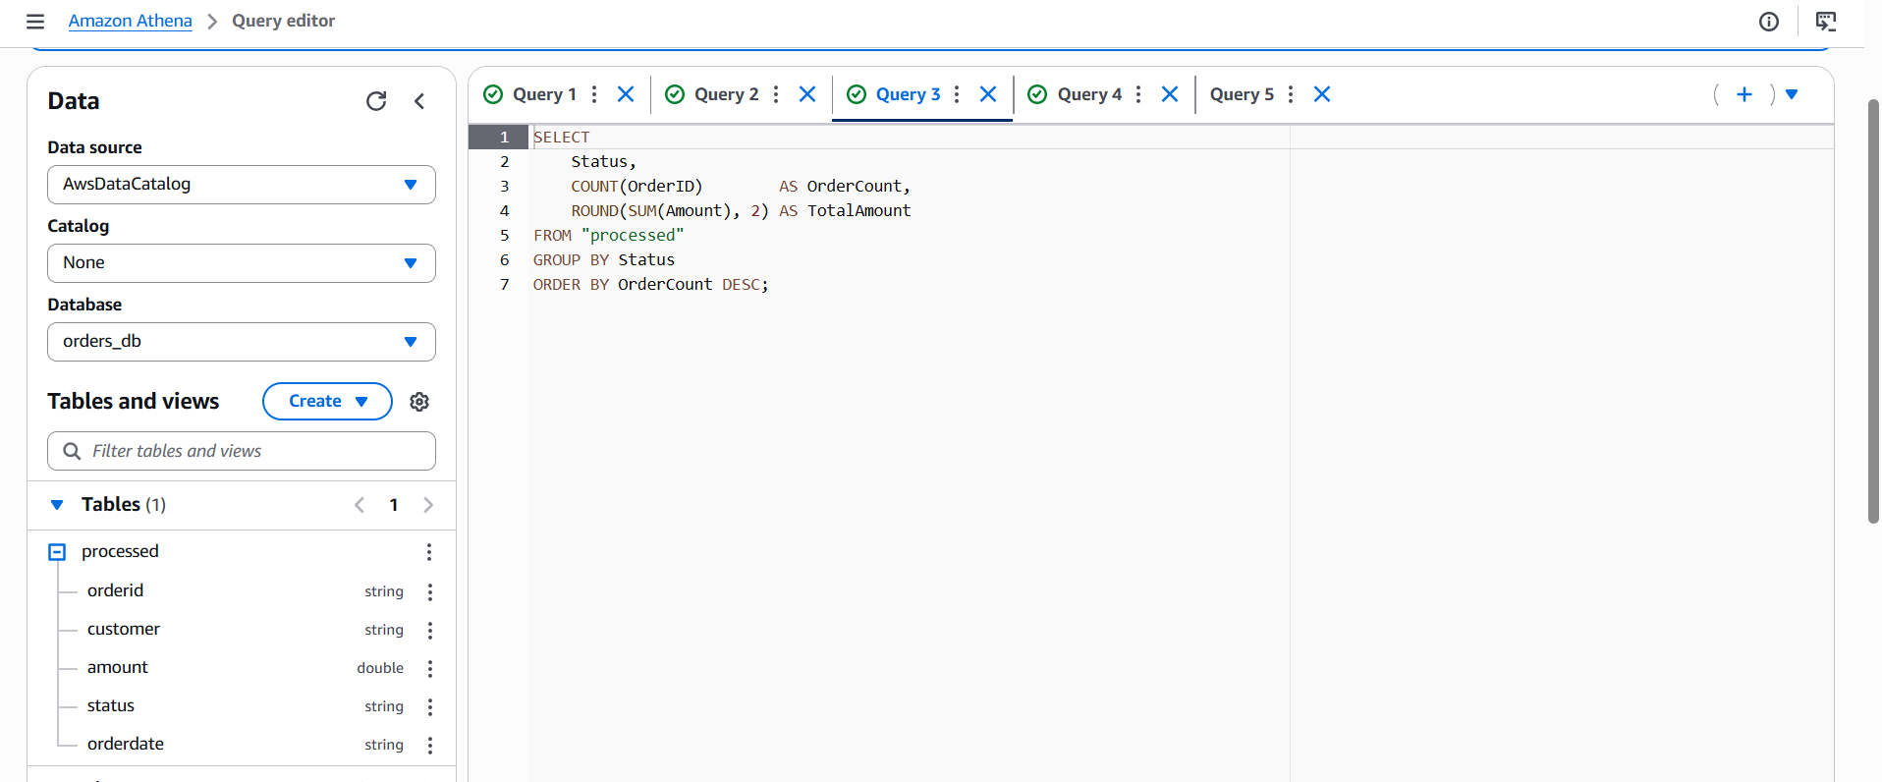

Query 4: Average Order Value (AOV) per Customer
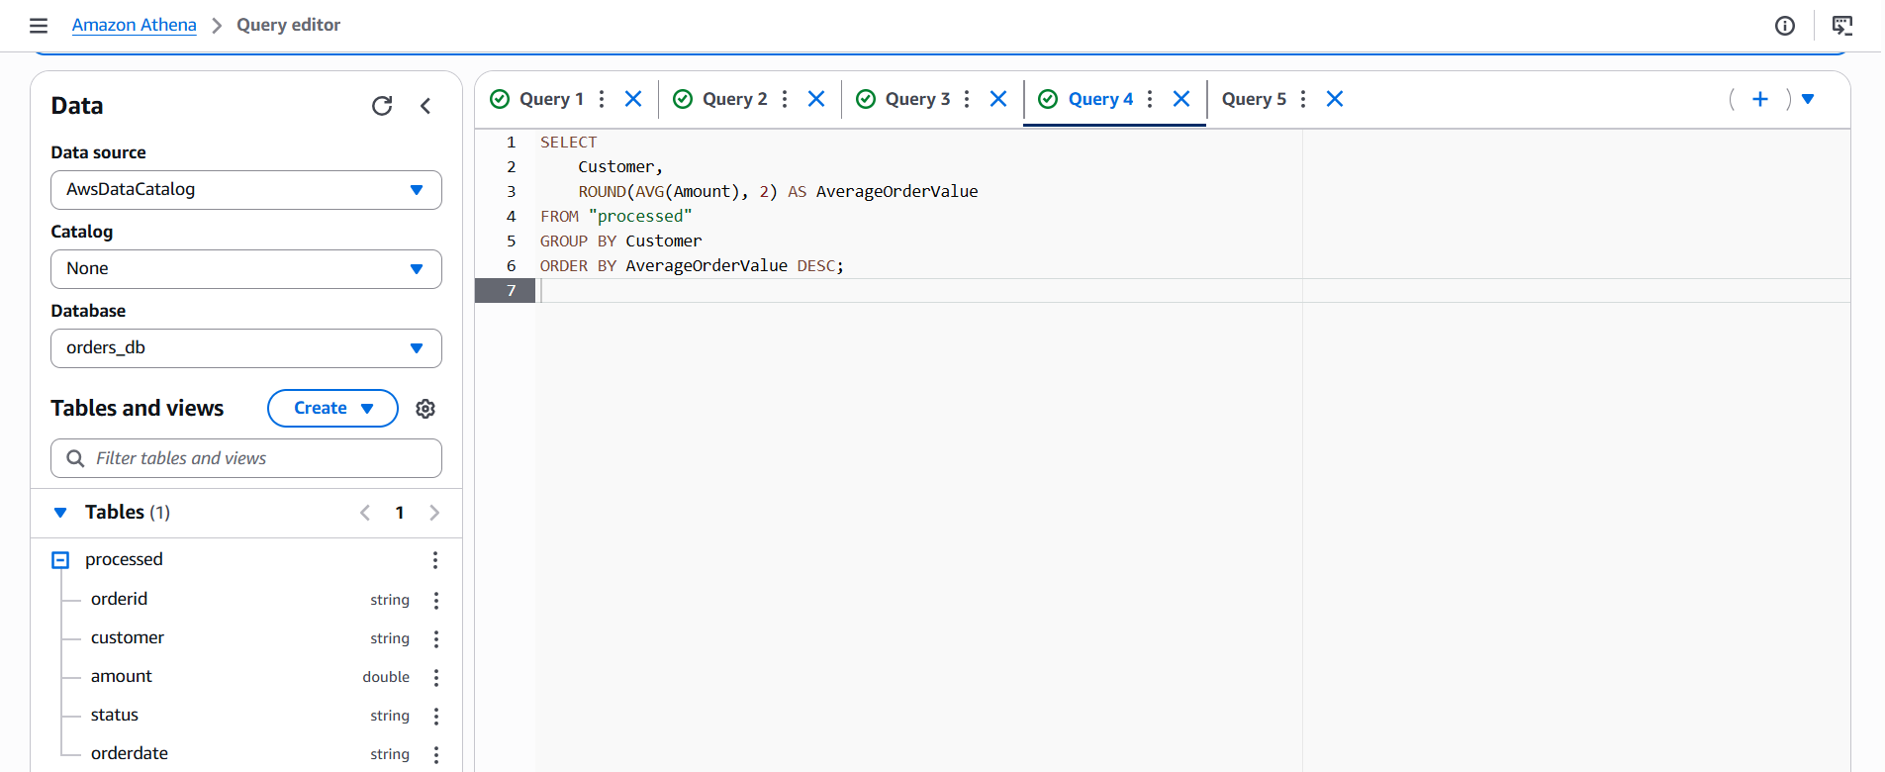

Query 5: Top 10 Largest Orders - February 2025
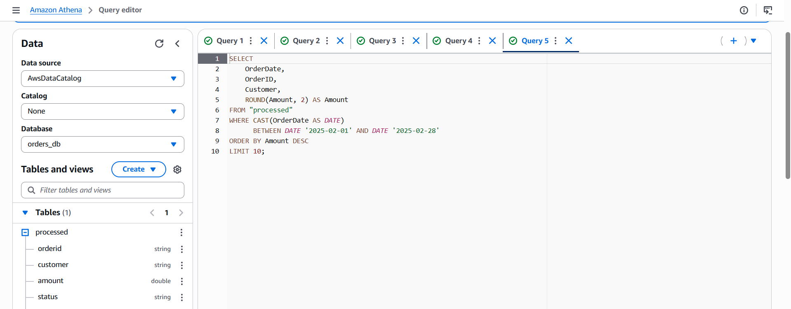

Step 7: EC2 Web Server 🖥️
Launched EC2 instance Athena-Dashboard-Server (t3.micro, Amazon Linux 2023, us-east-1d) with EC2-Athena-Dashboard-Role attached. Public IP: 98.83.211.207.

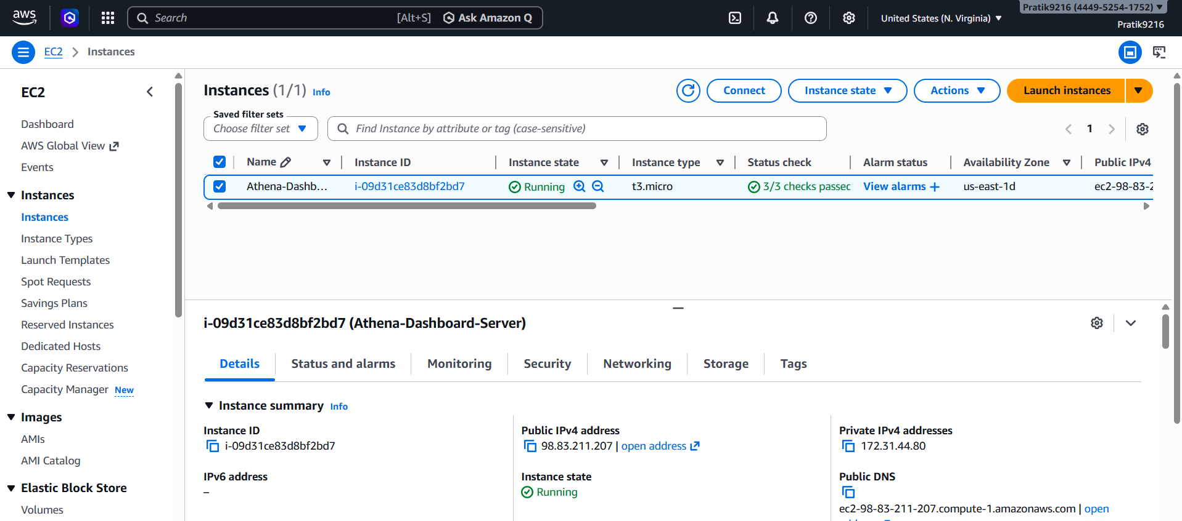
EC2 Instance: Athena-Dashboard-Server running (t3.micro, us-east-1d)

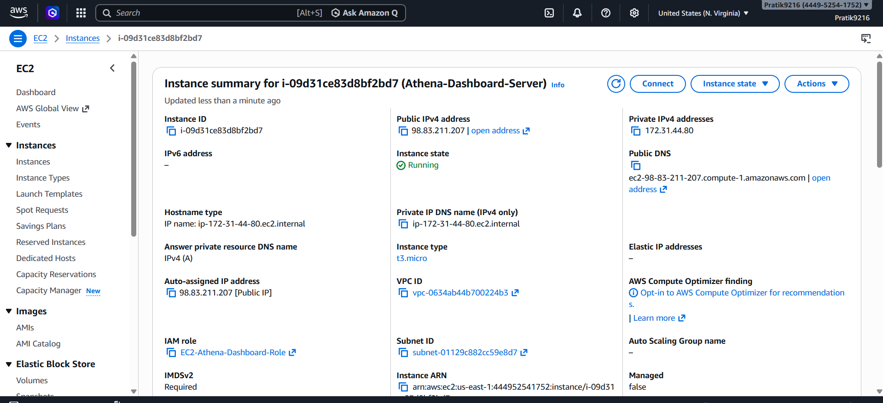
EC2 Instance Details: IAM Role EC2-Athena-Dashboard-Role attached, Public IP 98.83.211.207

Step 11: Athena Orders Dashboard 🚀
Flask web application running on EC2 at http://98.83.211.207:5000 successfully displaying all 5 Athena query results.

Query Result 1: Total Sales by Customer
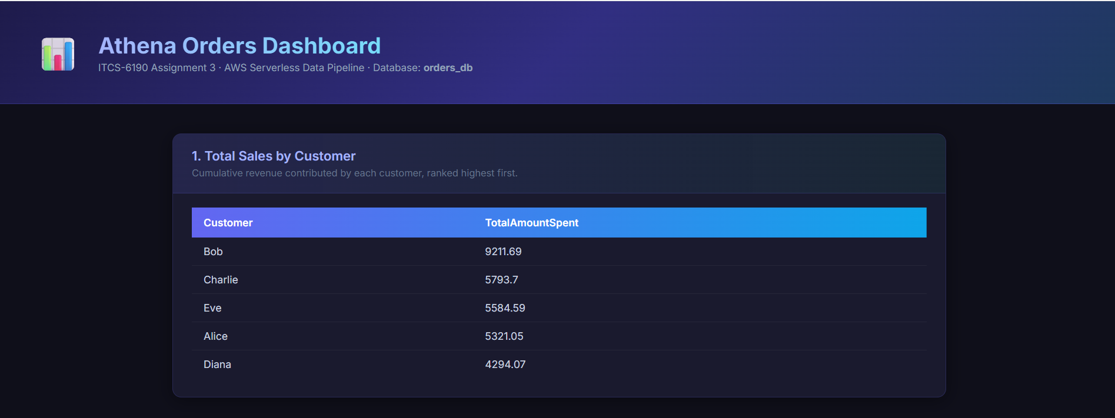

Query Results 2 & 3: Monthly Revenue and Order Status
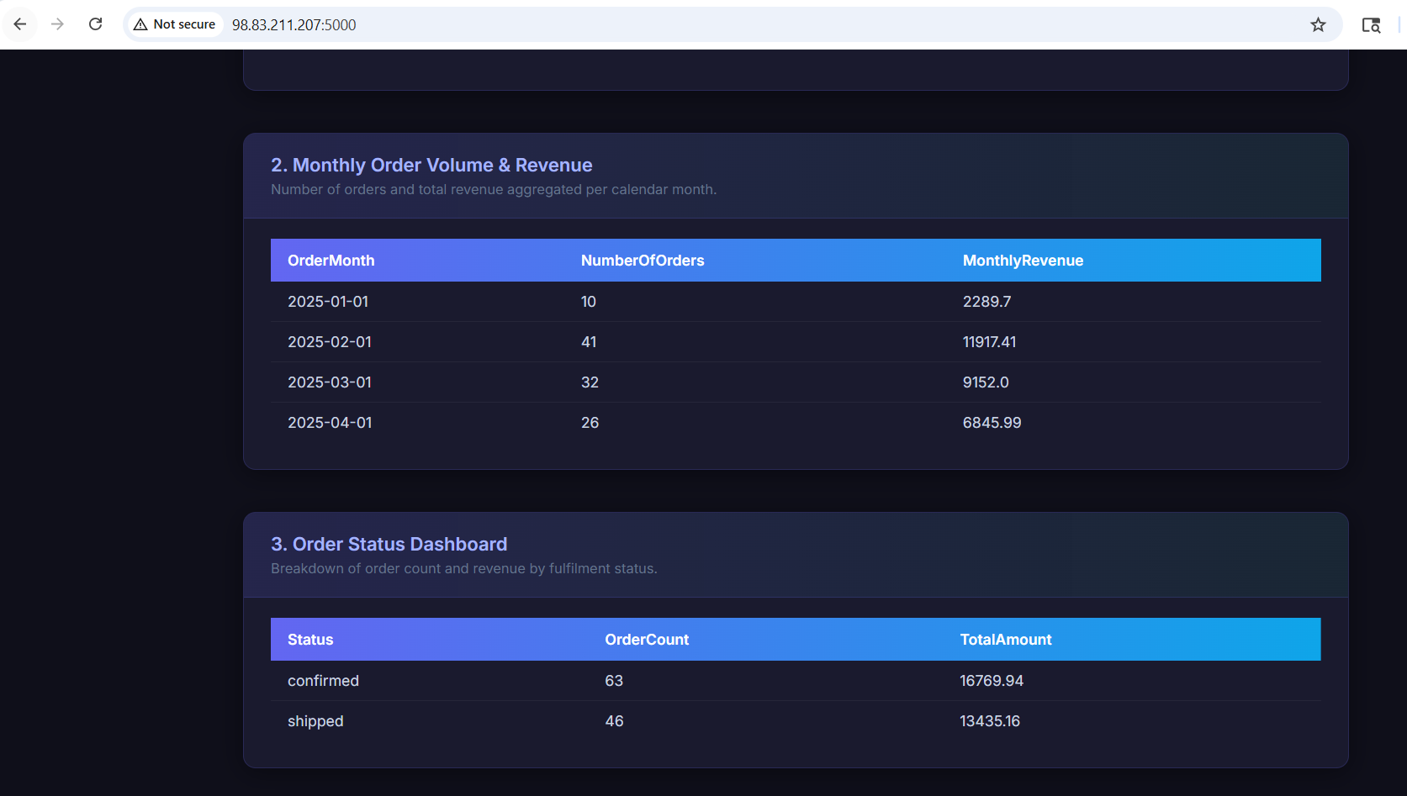

Query Result 4: Average Order Value per Customer
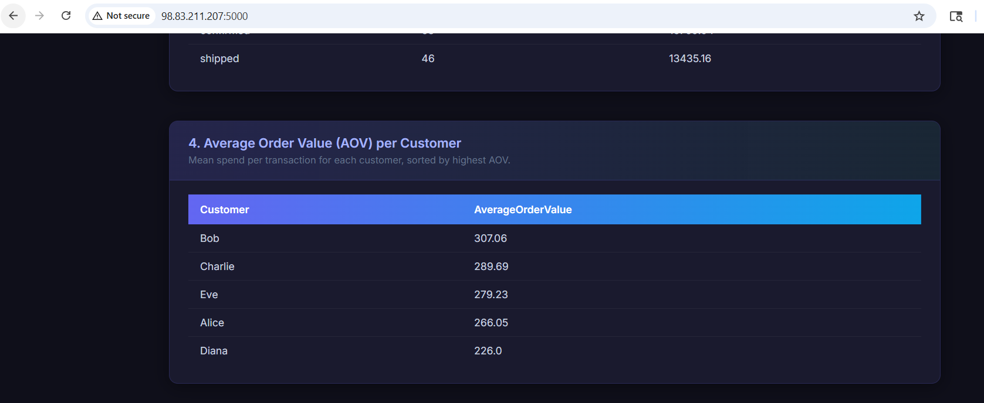

Query Result 5: Top 10 Largest Orders - February 2025
